SET 28
Question 1: Violin Plot of Fuel Efficiency by Safety Rating
Aim: To compare the distribution of fuel efficiency across safety-rating categories and examine spread, central tendency, and variability.

R Code
vehicles <- data.frame(
Vehicle_ID = c("V1", "V2", "V3", "V4", "V5"),
Engine_Size = c(1.5, 2.0, 3.0, 2.5, 1.8),
Horsepower = c(110, 150, 250, 200, 130),
Fuel_Efficiency = c(18, 15, 12, 14, 17),
Top_Speed = c(180, 200, 250, 220, 190),
Safety_Rating = c(4, 5, 5, 4, 3)
)
# Base R violin plot using vioplot package
install.packages("vioplot") # Run once if not installed
library(vioplot)
vioplot(
split(vehicles$Fuel_Efficiency, vehicles$Safety_Rating),
names = names(split(vehicles$Fuel_Efficiency, vehicles$Safety_Rating)),
xlab = "Safety Rating",
ylab = "Fuel Efficiency (km/l)",
main = "Fuel Efficiency by Safety Rating"
)
boxplot(Fuel_Efficiency ~ Safety_Rating, data = vehicles,
add = TRUE, at = seq_along(unique(vehicles$Safety_Rating)))
Output (illustrative plot generated from the given data):
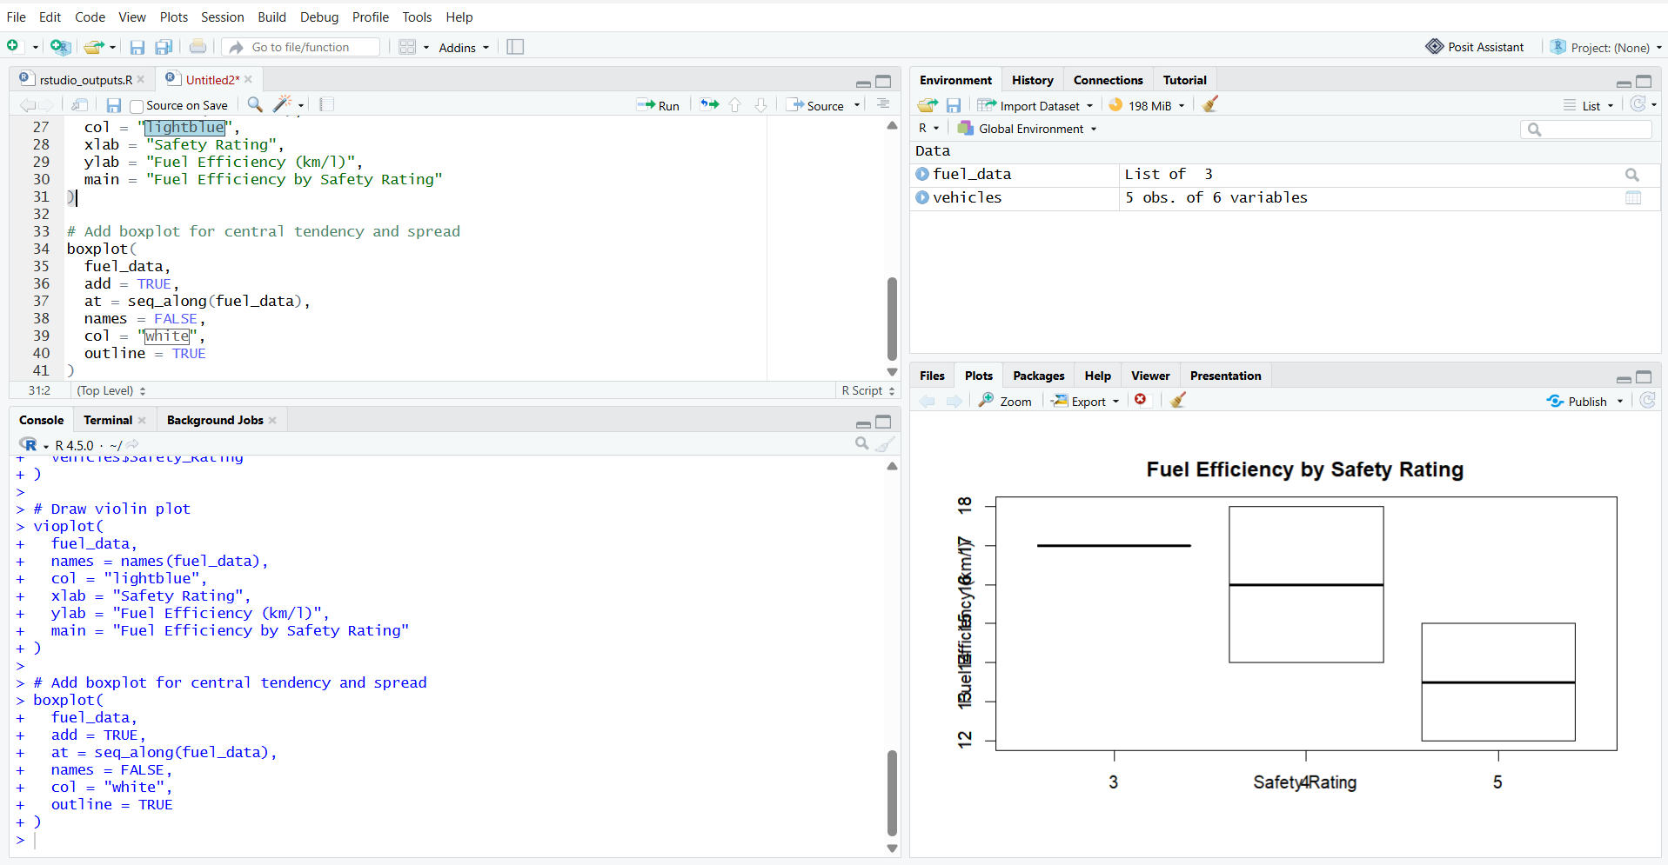

Question 2: Horsepower vs Top Speed Scatter Plot
Aim: To explore the relationship between horsepower and top speed, with points colored by engine size.

R Code
vehicles <- data.frame(
Vehicle_ID = c("V1", "V2", "V3", "V4", "V5"),
Engine_Size = c(1.5, 2.0, 3.0, 2.5, 1.8),
Horsepower = c(110, 150, 250, 200, 130),
Fuel_Efficiency = c(18, 15, 12, 14, 17),
Top_Speed = c(180, 200, 250, 220, 190),
Safety_Rating = c(4, 5, 5, 4, 3)
)
engine_colors <- c("1.5" = "blue", "2.0" = "red",
"3.0" = "darkgreen", "2.5" = "purple",
"1.8" = "orange")
plot(vehicles$Horsepower, vehicles$Top_Speed,
col = engine_colors[as.character(vehicles$Engine_Size)],
pch = 19, cex = 1.4,
xlab = "Horsepower", ylab = "Top Speed (km/h)",
main = "Horsepower vs Top Speed")
legend("topleft", legend = paste(names(engine_colors), "L"),
col = engine_colors, pch = 19, title = "Engine Size")
correlation <- cor(vehicles$Horsepower, vehicles$Top_Speed)
abline(lm(Top_Speed ~ Horsepower, data = vehicles),
col = "black", lwd = 2)
print(correlation)
Output (illustrative plot generated from the given data):
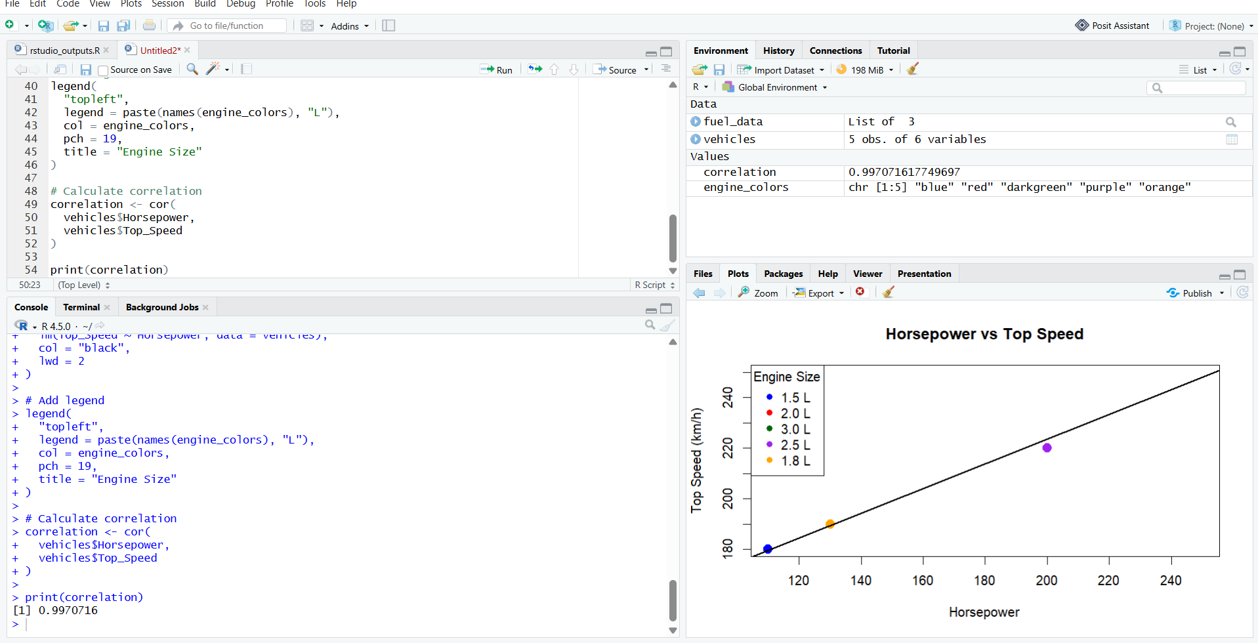

Question 3: Correlation Heatmap
Aim: To visualize correlations among all numerical variables and identify variables most strongly associated with top speed.

R Code
vehicles <- data.frame(
Engine_Size = c(1.5, 2.0, 3.0, 2.5, 1.8),
Horsepower = c(110, 150, 250, 200, 130),
Fuel_Efficiency = c(18, 15, 12, 14, 17),
Top_Speed = c(180, 200, 250, 220, 190),
Safety_Rating = c(4, 5, 5, 4, 3)
)
cor_matrix <- cor(vehicles)
print(round(cor_matrix, 2))
# Heatmap using base R
heatmap(cor_matrix, Rowv = NA, Colv = NA, scale = "none",
margins = c(8, 8), main = "Correlation Heatmap")
# Correlations specifically with Top_Speed
print(sort(cor_matrix[, "Top_Speed"], decreasing = TRUE))
Output (illustrative heatmap generated from the given data):
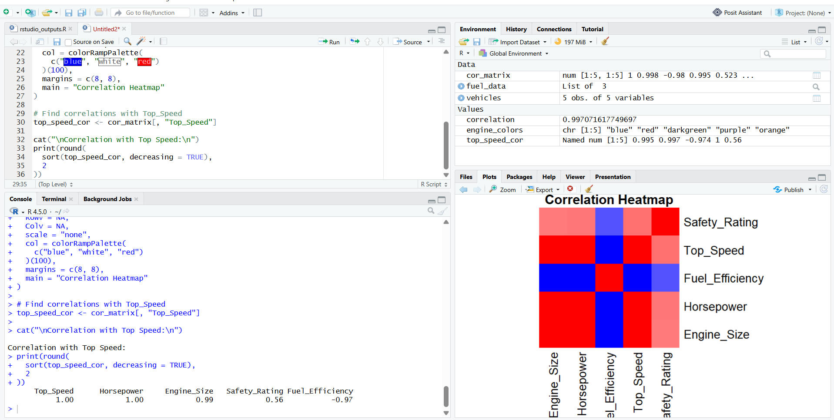

Question 4: Tableau Interactive Dashboard
Aim: To create a dashboard combining a bar chart and scatter plot with filters for engine size and safety rating, to identify vehicles balancing fuel efficiency and performance.
